

Programming Fundamentals

Assignment No 7

Student Name :MOMIN HAYAT KHAN

Roll No: S20-0273

Department :BS(Artificial Intelligence)

Batch / Year:SPRING 2020

Lecturer: Mam Misbah

One Dimensional Arrays and String

Program No 02:

Write a program in C++ that take age of five persons and then just display the age of each person by using arrays.

|  |
| --- |
| #include <iostream>  using namespace std;  int main()  {      int age[5];      for (int i = 0; i < 5; i++)      {          cout<<"Enter Age of person "<<i+1<<" : ";          cin>>age[i];      }      for (int j = 0; j < 5; j++)      {          cout<<"\nAge of Person "<<j+1<<" : ";          cout<<age[j];      }  } |

Output:

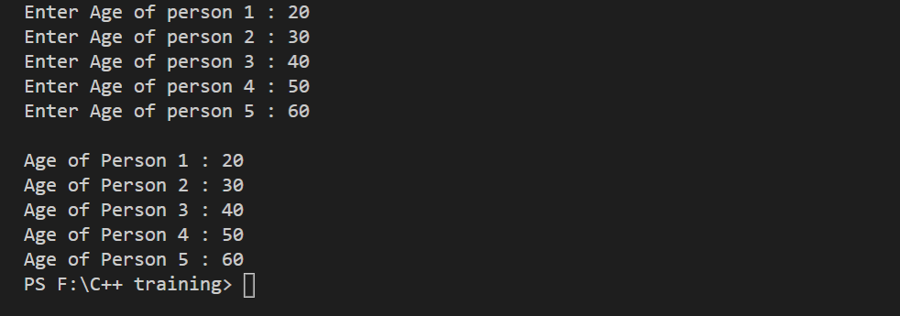

Program No 02:

Develop a Program that takes array elements from user and then transfer those elements to another array. Size of array will be 10.

|  |
| --- |
| #include <iostream>  #include<stdio.h>  #include <string.h>  using namespace std;  int main()  {      char Data[12];      char toget[12];      for (int i = 0; i < 10; i++)      {          cout<<"\nEnter Data"<<i+1<<" : ";          cin>>Data[i];      }      strcpy(toget,Data);      for (int k = 0; k < 10; k++)      {         cout<<toget[k]<<endl;      }  } |

Output:

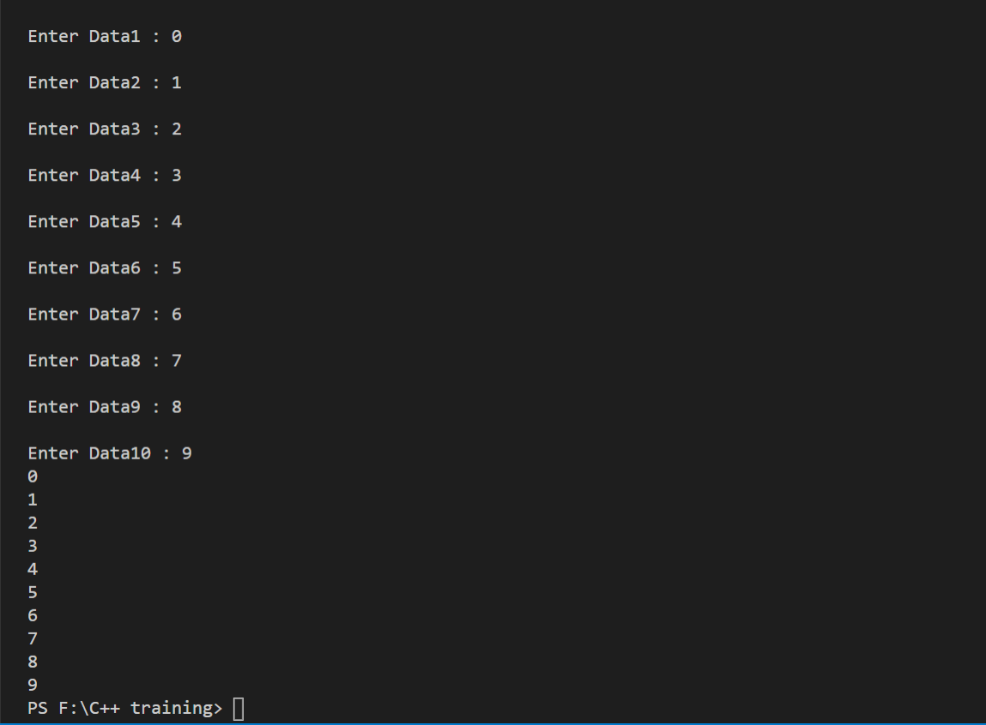

Program No 3:

Develop a program that takes 5 array elements from user. Swap position [2] element with position [4] element.

|  |
| --- |
| #include<iostream>  using namespace std;  int main()  {      int arry[5];      for (int i = 0; i < 5; i++)      {          cout<<"Enter value "<<i+1<<" : ";          cin>>arry[i];      }      int k=0;      while (k<5)      {          cout<<arry[k]<<endl;          k++;      }      cout<<endl;      //swapping positions      int var;      var=arry[2];      arry[2]=arry[4];      arry[4]=var;      int y=0;      while (y<5)      {          cout<<arry[y]<<endl;          y++;      }  } |

Output:

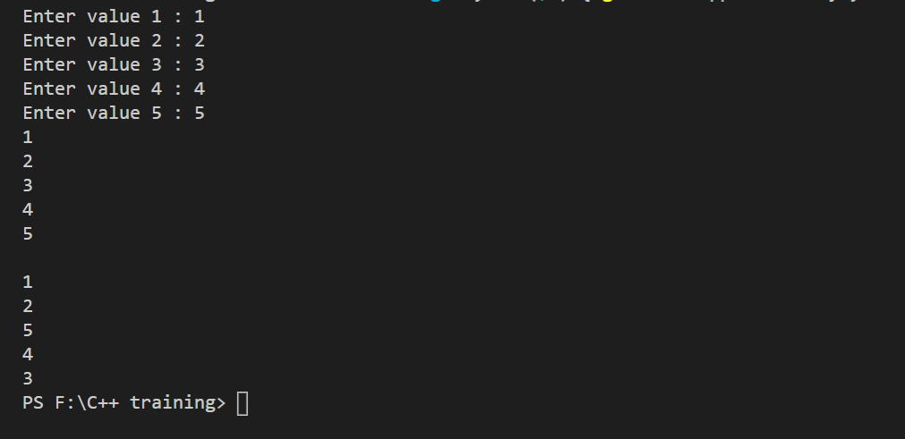

Program No 4:

Write a program to input data into two different arrays and then to add the two arrays and store the result in the third array.

|  |
| --- |
| #include <iostream>  using namespace std;  int main()  {      int arry1[5];      int arry2[5];      int arry3[5];      for (int i = 0; i < 5; i++)      {          cout<<"Enter Array A "<<i+1<<" : ";          cin>>arry1[i];      }      cout<<endl;      for (int j = 0; j < 5; j++)      {          cout<<"Enter Array B "<<j+1<<" : ";          cin>>arry2[j];      }      cout<<endl<<"Adding values to third array"<<endl;      for (int z = 0; z < 5; z++)      {          arry3[z]=arry1[z]+arry2[z];      }      cout<<endl<<"Adding values to third array"<<endl;      int t=0;      while (t!=5)      {          cout<<arry3[t]<<endl;          t++;      }  } |

Output:

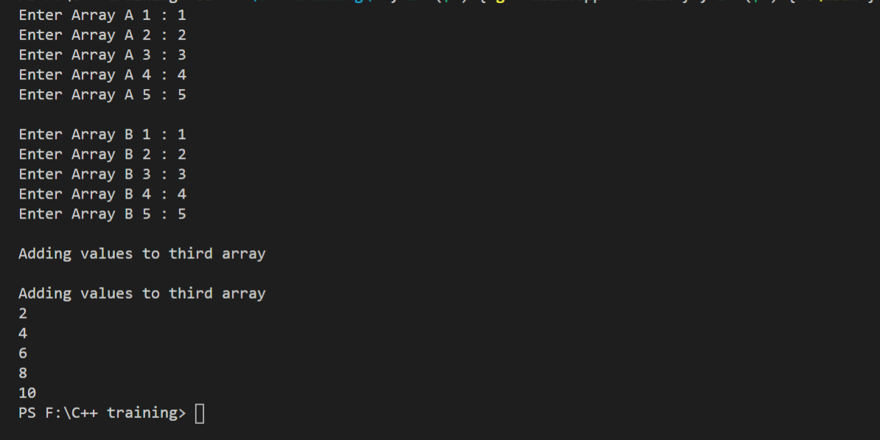

Program No 5:

Write a program in C++, to input data into an array. Enter a value from the Keyboard and find out the location of the entered value in the array. If the entered number is found in the array, display the message "Number Found―else display ―Number Not Found‖

|  |
| --- |
| #include <iostream>  using namespace std;  // void linearsearcch(int x[],int,int);  void linearsearch(int x[],int size,int key)  {      for (int i = 0; i <= size; i++)      {          if (x[i]==key)          {              cout<<"Number found";              break;          }          if (i==size)          {              cout<<"\nNumber not found";              break;          }      }  }  int main()  {      int arra[5]={3,5,2,8,9};      int key;      cout<<"Enter key to search in Array ";      cin>>key;      linearsearch(arra,5,key);    }} |

Output:

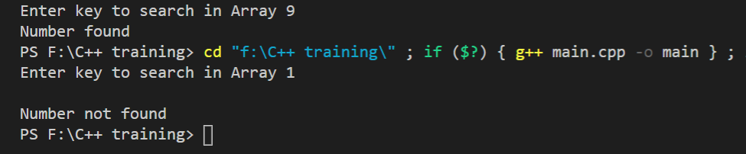

Program No 6:

Write a program that takes input from user and checks if the word is Palindrome or Not.

|  |
| --- |
| #include <iostream>  #include <string.h>  using namespace std;  int main()  {  char str1[20], str2[20];  int i, j, len = 0, flag = 0;  cout << "Enter the string : ";  gets(str1);  len = strlen(str1) - 1;  for (i = len, j = 0; i >= 0 ; i--, j++)  str2[j] = str1[i];  if (strcmp(str1, str2))  flag = 1;  if (flag == 1)  cout << str1 << " is not a palindrome";  els  cout << str1 << " is a palindrome";  return 0;  } |

Output:

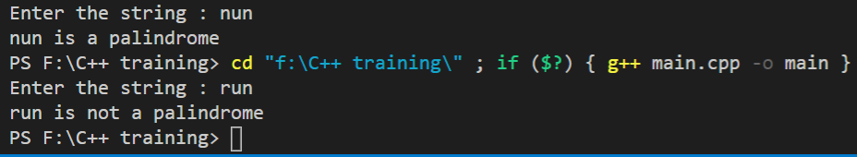

Program No 7:

Find the Average of 10 numbers passed to an array, using function. The Array should be controlled by while loop.

|  |
| --- |
| #include <iostream>  using namespace std;  void func()  {      int n=0;      double arry[10];      double average,add;      while(n<10){          cout<<"Integer values ";          cin>>arry[n];          n++;      }      for (int i = 0; i < 10; i++)      {          add=add+arry[i];        }      average=add/10;      cout<<average;  }  int main()  {      func();      return 0;  } |

Output:

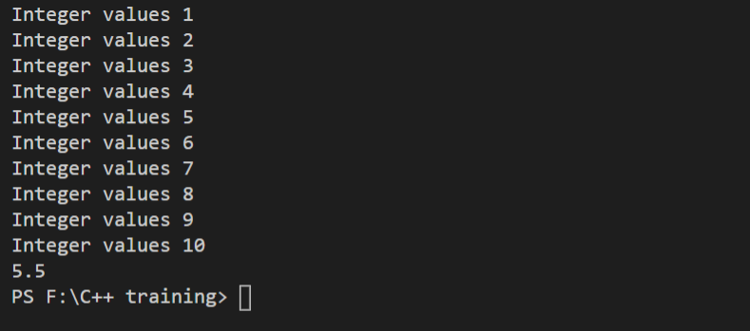Program No 8:

Write a Program in C++ that do the bubble sorting in Array. Hint

* Array Elements are entered by user in ―main function‖, the elements are user Defined. Terminate on *“zero”*
* Make a separate function *“sort()”* to do the bubble sort.
* Pass array elements to function *“sort()”.*
* Function should sort the array elements.
* Display the sorted array elements in main.

|  |
| --- |
| #include<iostream>  using namespace std;  void swapping(int &a, int &b) {     int temp;     temp = a;     a = b;     b = temp;  }  void display(int *array, int size) {     for(int i = 0; i<size; i++)        cout << array[i] << " ";     cout << endl;  }  void bubbleSort(int *array, int size) {     for(int i = 0; i<size; i++) {        int swaps = 0;        for(int j = 0; j<size-i-1; j++) {           if(array[j] > array[j+1]) {              swapping(array[j], array[j+1]);              swaps = 1;           }        }        if(!swaps)           break;     }  }  int main() {     int n;     cout << "Enter the number of elements: ";     cin >> n;     int arr[n];     cout << "Enter elements:" << endl;     for(int i = 0; i<n; i++) {        cin >> arr[i];     }     cout << "-----Array before Sorting-----"<<endl;     display(arr, n);     bubbleSort(arr, n);     cout << "-----Array after sorting-----"<<endl;     display(arr, n);  } |

Output:

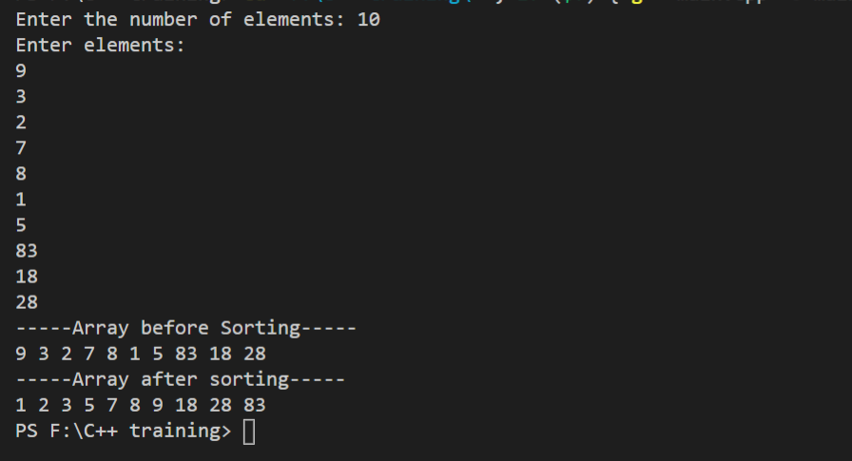

Program No 9:

Write a program that gets the name from user and then print back on the screen.

|  |
| --- |
| #include <iostream>  using namespace std;  int main()  {     int max =12;     char str [max];     cout<<"\nEnter a string:";     cin>>str;     cout<<"\nYou entered: "<<str<<endl;     return 0 ;  } |

Output:

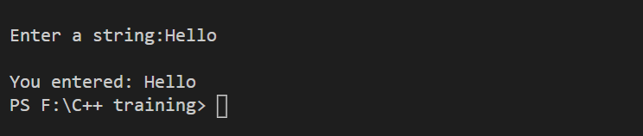

Program No 10:

Write a program that gets the name from user and then print back on the screen using gets and puts functions.

|  |
| --- |
| #include <iostream>  using namespace std;  int main()  {     int max =12;     char str [max];     cout<<"\nEnter a string:";     cin.get(str,max);     cout<<"\nYou entered: "<<str<<endl;     return 0 ;  } |

Output:

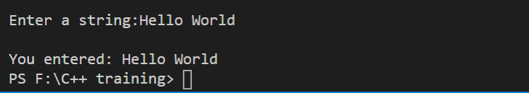

Program No 11:

strcpy and strcmp

|  |
| --- |
| #include <stdio.h>  #include <string.h>  #include<iostream>  using namespace std;  int main() {     char str1[20] = "C++ programming";     char str2[20];     strcpy(str2, str1);     puts(str2);     int a=strcmp(str1,str2);     cout<<a;     return 0;  } |

Output:

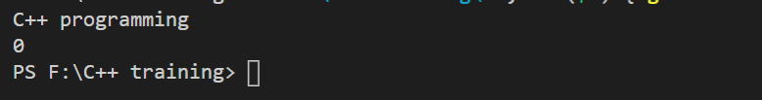

Program No 12:

Write a program in C++ that take string from user and then enter the position to delete. Make a separate function for string deletion.

|  |
| --- |
| #include <iostream>  using namespace std;  void delet()  {     char arr[20];     cout<<"Enter word : ";     cin.get(arr,20);     cout<<"Enter position for deletion of character : ";     int p;     cin>>p;  for (int i = p; i < 20; ++i)      arr[i] = arr[i + 1];  int a=0;  while (a<20)  {     cout<<arr[a];     a++;  }  }  int main()  {     delet();     return 0;  } |

Output:

